ASSIGNMENT 8.1
Name: N. Shiva
Htno:2403A51298
Batch:24btcscai12
Task #1: Password Strength Validator – Apply AI in
Security Context
Prompt:
Write a Python function is_strong_password(password) and use AI to first generate at least 3 assert test cases based on password rules (length, uppercase, lowercase, digit, special character, no spaces). Then implement the function so it passes all test cases.
Code:
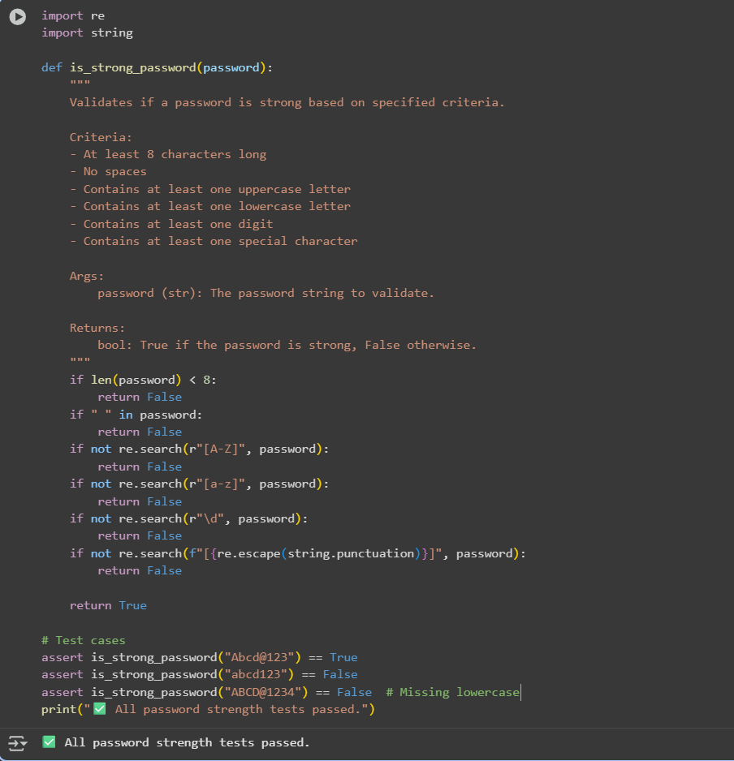
Task #2: Number Classification with Loops – Apply AI for
Edge Case Handling
prompt:
Create a Python function classify_number(n) and ask AI to generate at least 3 assert test cases, including edge cases (negative, zero, positive, invalid input). Implement the function using loops to classify inputs as Positive, Negative, or Zero while handling invalid cases
Code:
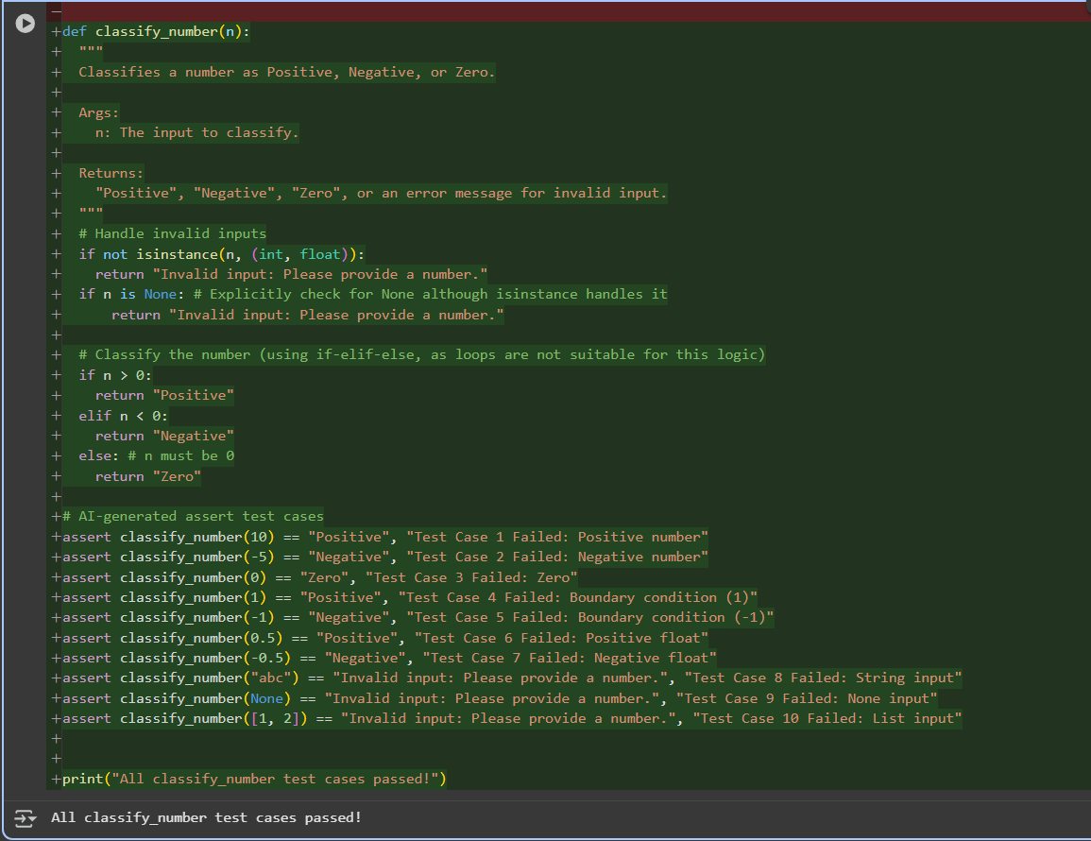

Task #3: Anagram Checker – Apply AI for String Analysis)
Prompt:
Ask AI to generate at least 3 assert test cases for a Python function is_anagram(str1, str2) that checks if two strings are anagrams. Implement the function so it ignores case, spaces, and punctuation, and passes all test cases, including edge conditions.
Code:
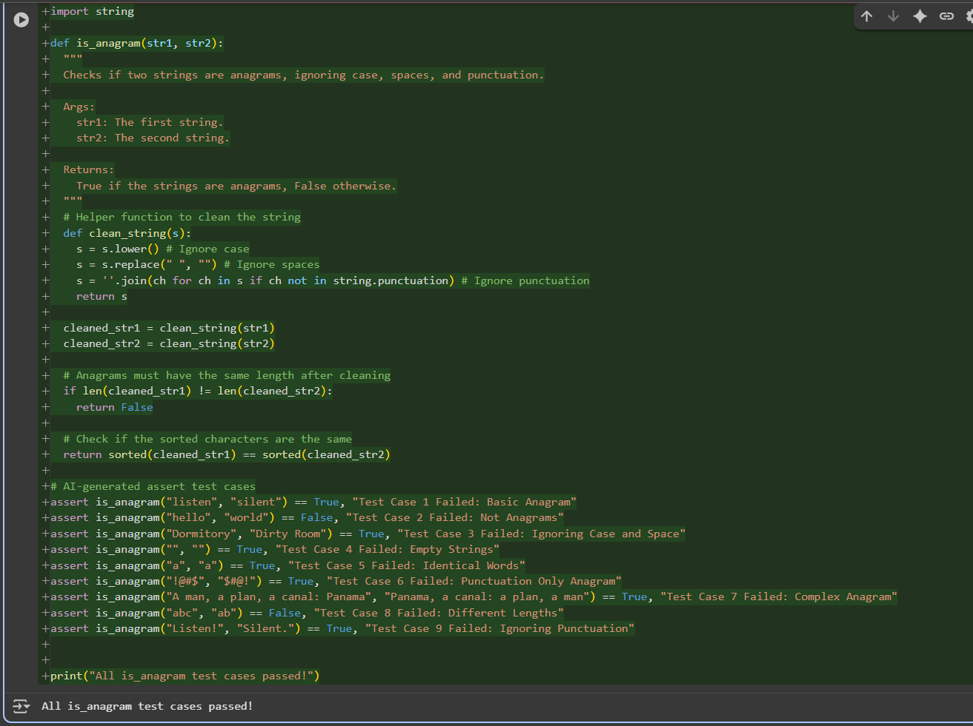
Task #4: Inventory Class – Apply AI to Simulate Real-
World Inventory System
Prompt:
Ask AI to generate at least 3 assert test cases for an Inventory class in Python that manages stock. Implement methods add_item(name, quantity), remove_item(name, quantity), and get_stock(name). Ensure the class passes all AI-generated test cases and works correctly in real-world inventory simulation.
Code:
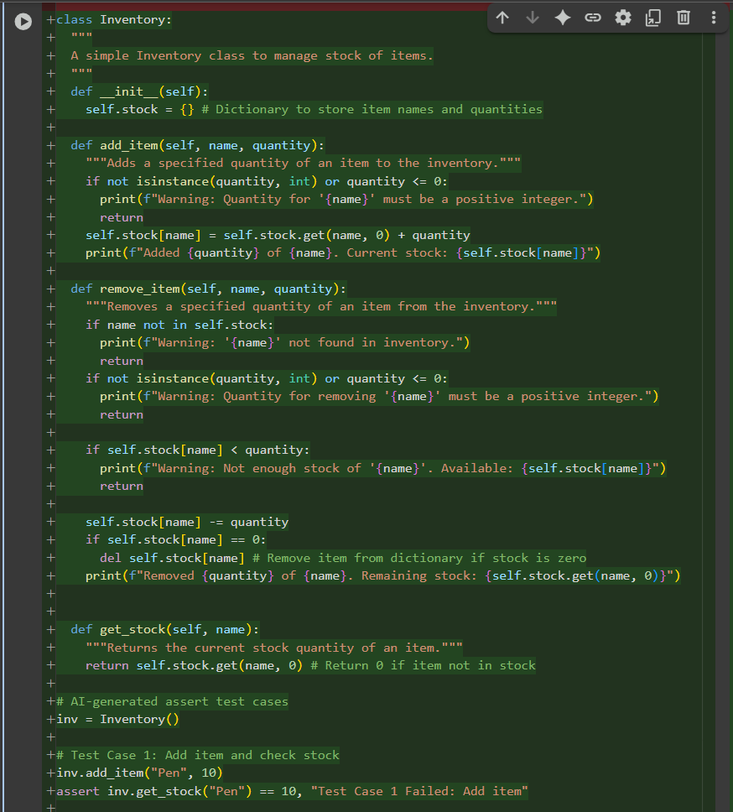
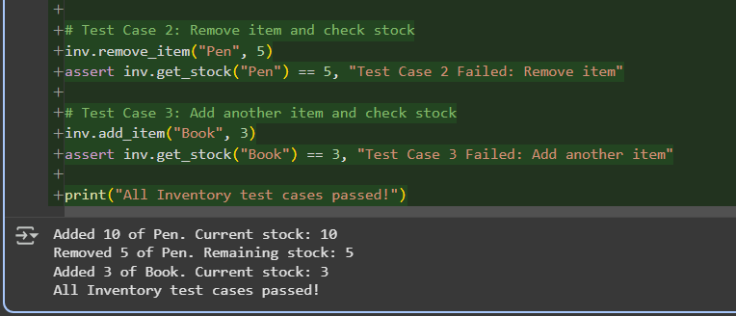
Task #5: Date Validation & Formatting – Apply AI for
Data Validation
Prompt:
Ask AI to generate at least 3 assert test cases for a function validate_and_format_date(date_str) that validates dates in 'MM/DD/YYYY' format. The function should return dates in 'YYYY-MM-DD' format if valid or 'Invalid Date' if not. Implement the function so it passes all test cases, including edge cases
Code:
